**Lab-2**

**ARTIFICIAL INTELLIGENCE**



**Title:** - **Implement Informed searching Technique/s**

**(A* Algorithm)**

**Group Details:**

**Group No: TY-12 Div.: B Batch: B-3**

|  |  |  |  |
| --- | --- | --- | --- |
| **Sr.No** | **Name** | **Roll.No** | **Gr.No** |
| 1 | Shubham Kakde | 49 | 11811244 |
| 2 | Sidharth Kakde | 50 | 11811170 |
| 3 | Vedant Katti | 55 | 11810142 |
| 4 | Vinayak Kokane | 58 | 11810499 |
| 5 | Dhanraj Kore | 60 | 11810970 |

**Implementation:**

def aStarAlgo(start_node, stop_node):

        open_set = set(start_node)

        closed_set = set()

        g = {} #store distance from starting node

        parents = {}# parents contains an adjacency map of all nodes

        #ditance of starting node from itself is zero

        g[start_node] = 0

        #start_node is root node i.e it has no parent nodes

        #so start_node is set to its own parent node

        parents[start_node] = start_node

        while len(open_set) > 0:

            n = None

            #node with lowest f() is found

            for v in open_set:

                if n == None or g[v] + heuristic(v) < g[n] + heuristic(n):

                    n = v

            if n == stop_node or Graph_nodes[n] == None:

                pass

            else:

                for (m, weight) in get_neighbors(n):

                    #nodes 'm' not in first and last set are added to first

                    #n is set its parent

                    if m not in open_set and m not in closed_set:

                        open_set.add(m)

                        parents[m] = n

                        g[m] = g[n] + weight

                    #for each node m,compare its distance from start i.e g(m) to the

                    #from start through n node

                    else:

                        if g[m] > g[n] + weight:

                            #update g(m)

                            g[m] = g[n] + weight

                            #change parent of m to n

                            parents[m] = n

                            #if m in closed set,remove and add to open

                            if m in closed_set:

                                closed_set.remove(m)

                                open_set.add(m)

            if n == None:

                print('Path does not exist!')

                return None

            # if the current node is the stop_node

            # then we begin reconstructin the path from it to the start_node

            if n == stop_node:

                path = []

                while parents[n] != n:

                    path.append(n)

                    n = parents[n]

                path.append(start_node)

                path.reverse()

                print('Path found: {}'.format(path))

                return path

            # remove n from the open_list, and add it to closed_list

            # because all of his neighbors were inspected

            open_set.remove(n)

            closed_set.add(n)

        print('Path does not exist!')

        return None

#define fuction to return neighbor and its distance

#from the passed node

def get_neighbors(v):

    if v in Graph_nodes:

        return Graph_nodes[v]

    else:

        return None

#for simplicity we ll consider heuristic distances given

#and this function returns heuristic distance for all nodes

def heuristic(n):

        H_dist = {

            'S': 14,

            'B': 12,

            'C': 11,

            'D': 6,

            'E': 4,

            'F': 11,

            'G': 0,

        }

        return H_dist[n]

#Describe your graph here

Graph_nodes = {

    'S': [('B', 4), ('C', 3)],

    'B': [('F', 5),('E', 12)],

    'C': [('E', 12),('D', 2)],

    'F': [('G', 16)],

    'E': [('G', 5)],

    'D': [('E', 2)],

}

aStarAlgo('S', 'G')

**Problem:**

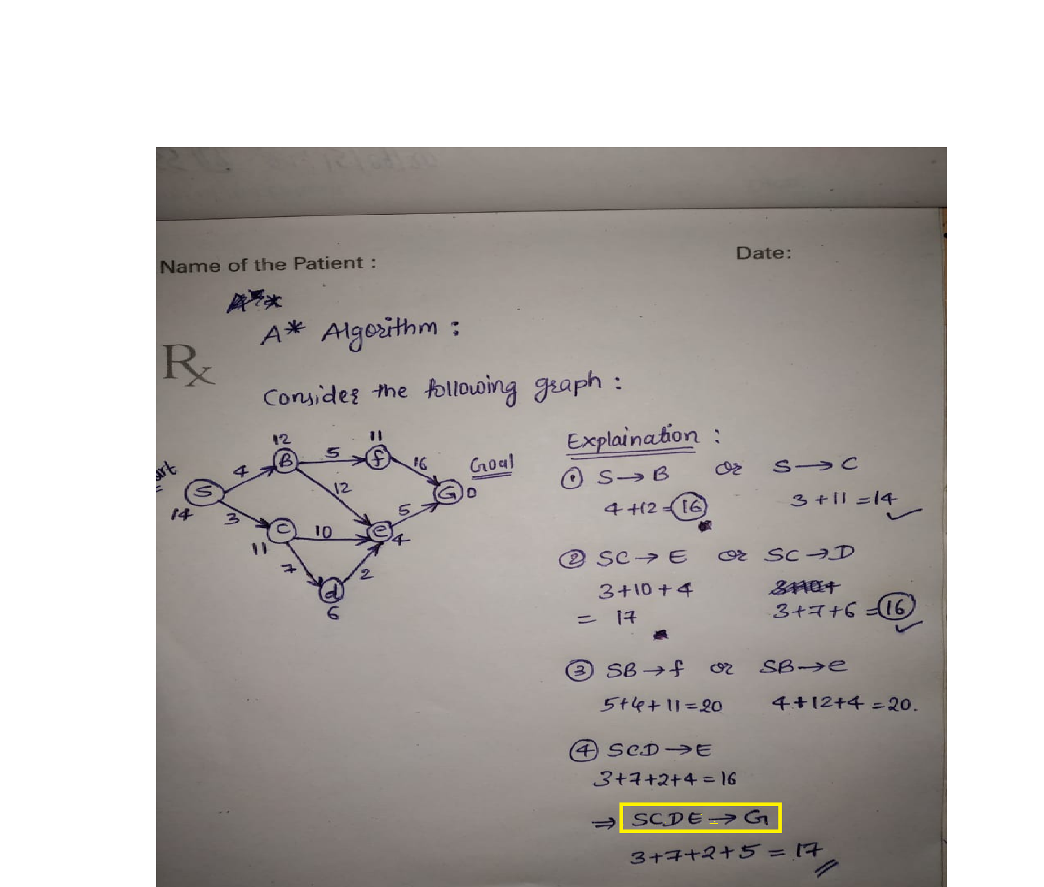

**O/P:**

